**Chapter 3**

**METHODOLOGY**

**3.1 Introduction**

The main objective of this study is to create a system that translates an image of a Gregg shorthand stroke into its corresponding English word. This shall help in translating documents in Gregg shorthand easier for stenography newbies or even to non-shorthand writers. To accomplish this, the researchers shall use Optical Character Recognition (OCR) with k-Nearest Neighbors (k-NN) algorithm.

An overview of the research process shall be discussed in this chapter. Information regarding the *insert parts here* shall be provided. This chapter shall serve its purpose to explain the design and implementation process as well as the methods to be used to create the proposed system.

* 1. **Experimental Design**

Experimental method shall be applied for this study. Concepts that shall be utilized include computer vision, image processing, and machine learning. The researchers shall take into account factors that are vital to the integrity of the proposed system. Factors include diversity and amount of the training data, accuracy of the Gregg shorthand translation, and user satisfaction. In times when a Gregg shorthand document needs to be translated but a stenographer is not present, the proposed system shall alleviate such problem. For learners of the writing system, it can be used as a tool to aid learning.

**3.2.1 Research Procedure**

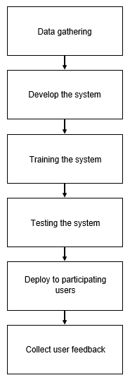

**Figure N Research Procedure Block Diagram**

[insert paragraph here]

**3.2.1 Software Development Life Cycle**

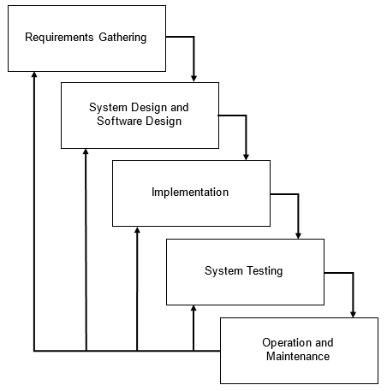

**Figure N Iterative Waterfall Model**

For the life cycle of the software development, the iterative waterfall model shall be used as seen in Figure N. Similarly to the classical waterfall model, this model allows the researchers to approach the development of the system in an organized manner which also has the flexibility of going back to certain stages after gathering feedback which results to parts of the system that needs to be redone.

Requirements gathering includes gathering of training and testing data. The training data is composed of 15.280 English words from an open-source Gregg Shorthand dictionary. Meanwhile, the test data shall be collected from BS Office Administration student volunteers whom shall write in Gregg Shorthand on a clean bond paper. Designing the software is the next step wherein the OCR algorithm along with a KNN model shall be used to pre-process the data images which shall be used for training. Once the design is polished, the implementation shall commence. Following is the testing for the accuracy and operation and maintenance.

**3.2.2 System Flow**

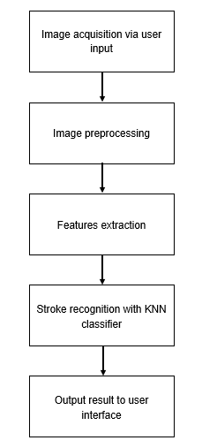

**Figure N System Flow Diagram**

As seen on Figure N, the system first acquires an image from the user which will then undergo preprocessing which includes converting to grayscale, blurring, thresholding, and converting to a binary image. After the features are extracted, these will be fed to the KNN classifier for the stroke to be recognized and translated to its corresponding English word. The result shall then be displayed to the user interface.

**Image Preprocessing**

***** The fare collection system of our study is the hardware side of our system. It allows bus passengers to pay their fare using their cards. The passenger must receive a card that has been registered to the system and has a load inside it for subsequent payment. Passengers would swipe their cards in front of the RFID reader prior to the journey. After detecting it, the RFID reader would then read the UID (Unique IDentifier) or the serial number from the card and store it on the database server. The GPS module would then obtain the coordinates of the passenger's origin, which would be saved on the database server and will be displayed on the LCD. *****

**K-Nearest Neighbours Classifier**

***** The management system is the software side of our system. This contains information about the fare collection data and contact tracing information. The fare collecting data is a section of the software that stores data that was gathered from the RFID reader and GPS module such as the number of passengers, the UID or card serial number of the passenger's card, their origin location, their destination location, and their total fare. The contact tracing information is a section in the software that will store the contact information of the passenger such as their UID or card serial number, date and time they entered the bus, their name, address and contact number. The software also has a section on registering the passenger’s card and the admin’s setting. *****

**3.3 Statistical Treatment**

A confusion matrix shall be utilized to calculate the accuracy of the system. The said matrix is a two-by-two table which contains false positives, false negatives, true positives, and true negatives for a test. In this study, the following definitions are made of the classes:

* “Gregg shorthand stroke” is the positive class
* “Non-Gregg shorthand stroke” is the negative class

|  |  |  |  |
| --- | --- | --- | --- |
|  | | **Predicted** | |
| **Negative** | **Positive** |
| **Actual** | **Negative** | True Negative (TN) | False Positive (FP) |
| **Positive** | False Negative  (FN) | True Positive (TP) |

**Table N Confusion Matrix for system accuracy evaluation**

As seen on Table N, an actual non-Gregg shorthand stroke predicted as is, yields a true negative result. False negative is the result for an actual Gregg shorthand stroke predicted as the contrary. False positive is the result of an actual non-Gregg shorthand stroke predicted as the opposite. A Gregg shorthand stroke actual value predicted as is, results to a true positive.

The accuracy of the system is defined as:

$$Accuracy= \frac{TP+TN}{TP+TN+FP+FN}$$

[insert here]